**17. Accessing WordNet Using NLTK**

**Aim:**  
To use WordNet for retrieving synsets and exploring word meanings.

**Algorithm:**

1. Import the WordNet library from NLTK.
2. Retrieve synsets for a given word.
3. Display definitions, examples, and related words.

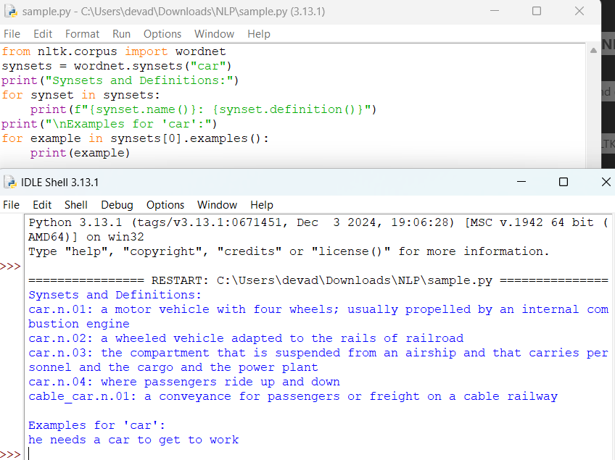

**Result:**  
Synsets and related information for the word "car" are retrieved successfully.